**Home Equity Reverse Mortgage Information Technology**

**(HERMIT)**

**HERMIT System Changes – Release 5.9**

**Release Date: 11/09/19**

**Document Date: 11/04/19**

November 2019

**INTRODUCTION**

The Home Equity Reverse Mortgage Information Technology (HERMIT) software release version 5.9 consists of the following system changes:

Table of Contents

Servicer Related Changes 2

1. Appraisal Tracking 2

2. Actual Claim Paid Date 4

3. Prevent CT24 filing after 6 month Deadline 4

4. Allow negative value in Block 108 on Claim Type 24 7

5. Multiple / Subsequent Claim Type 24 Supplementals 7

NSC Related Changes 10

6. New Request- Substitution of Collateral Timeline 10

7. New Add new steps to Claim Type 22 - Assignment timeline 16

8. Servicer access to loan with Servicer = HUD via Endorsed/Claims/Search page 17

9. New Add new step to Write-Off Timeline 18

If you have any questions regarding the functionality of the software release, please contact the HERMIT Help Desk at 561-899-2610 or at [servicingsupport@hermitsp.com](mailto:support@hecmsp.com). If you have any policy related questions, please send an email to HUD at [answers@hud.gov](mailto:answers@hud.gov).

# Servicer Related Changes

## Appraisal Tracking

With the recent focus on the appraisal process of the HECM program, HUD requested an enhancement to track Appraisals on the existing Property Values page so claims examiners and auditors can quickly compare the values of ALL appraisals obtained during the default/claims process. Previously, to compare appraisal values a reviewer must open separate documents in HERMIT manually to obtain the value.

The Property Value page in HERMIT has been updated to reflect more detailed Property Value information. Prior to submitting a claim all appraisal information must be entered on the Loan Module’s **Property > Property Values** page.

A red asterisk denotes a required field. The new and changed fields are displayed in blue font:

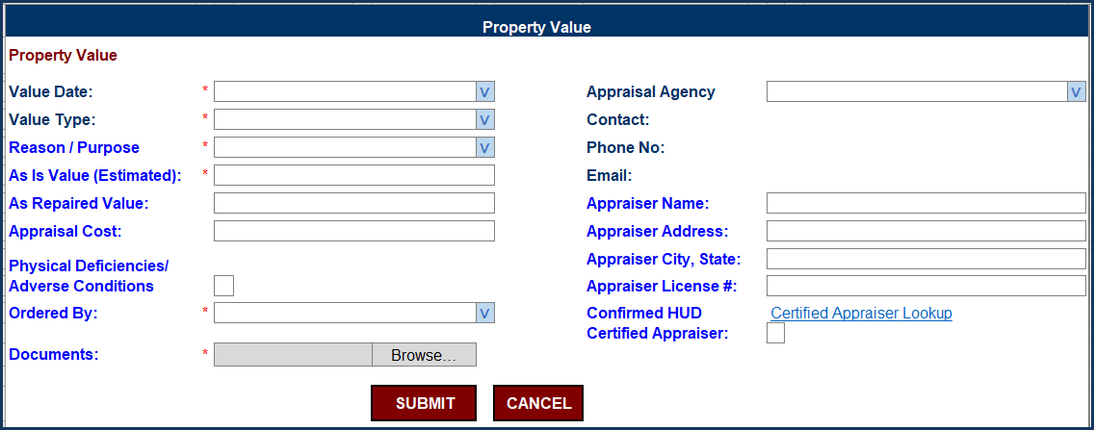

Figure 1: Updated Property Values New and Edit screen

1. Changes to **Value Type** dropdown:
   1. Removed: “Appraisal Value” and “Drive By/Inspection” were inactivated and cannot be selected going forward. For values already entered, the value type will remain as originally entered.
   2. New: “Appraisal – Full Interior”, “Appraisal – Land Only”, and “Appraisal – Manufactured Home” and “Appraisal – Drive-By/Exterior”.
2. New “**Reason / Purpose**” dropdown field options:
   1. Default
   2. Foreclosure Bidding
   3. Short Sale
   4. SBC 6 Month Marketing
   5. Appraisal Based Claim
   6. Other Reason
3. New “**Ordered By**” dropdown field options:
   1. Servicer
   2. Investor
   3. Borrower
   4. Estate/Heirs
   5. HUD
   6. Other
4. Certain fields are conditionally required and when selected additional fields will be required. For other selections the field is optional. **The user must enter all required fields in order to save the Property Value / appraisal record.**
5. Attaching Documents: A PDF document must always be attached to save the Property Value record. The document attached to the Property Value record may be replaced with another document; and the original document is retained in the Loan Module > Documents page.

Additional Property Value field details:

| **Fields** | **Description of changes** |
| --- | --- |
| **Value Date:** | (No Changes) |
| **Value Type:** | Updated Dropdown list selections |
| **Reason / Purpose** | New Dropdown list |
| **As Is Value (Estimated):** | Renamed field from "Estimated Value" to "As Is Value (Estimated)" |
| **As Repaired Value:** | Renamed field from "Repair Value" to "As Repaired Value" |
| **Appraisal Cost:** | This field is always displayed. For certain Value Types this field is required, for other value types the field is optional |
| **Physical Deficiencies/ Adverse Conditions** | New Check box |
| **Ordered By:** | New dropdown field |
| **Documents:** | New Document Upload field. **Document is always required.** |
| **Appraisal Agency** | (No Changes) |
| **Contact:** | (No Changes) |
| **Phone No:** | (No Changes) |
| **Email:** | (No Changes) |
| **Appraiser Name:** | Text input by user. The field is always displayed and required for certain Value Types, for other value types the field is optional |
| **Appraiser Address:** | Text input by user. The field is always displayed and required for certain Value Types, for other value types the field is optional |
| **Appraiser City, State:** | Text input by user. The field is always displayed and required for certain Value Types, for other value types the field is optional |
| **Appraiser License #:** | Text input by user |
| **Confirmed HUD** | Checkbox and the link for the HUD Certified Appraiser webpage: will be displayed. User can click the link and verify the appraiser is on the list, then check the box to indicate “True” or “Yes”. **https://entp.hud.gov/idapp/html/apprlook.cfm** |
| **Certified Appraiser:** |

Figure 2: Property Value screen details

## Actual Claim Paid Date

The “Claim Paid” step completion date and scheduled date on the claims timelines in HERMIT have been updated to reflect the Treasury Claim Paid date provided in the Accounting Claim_Status file. This is the date Treasury paid the claim. This applies to Claim Types 21, 22, 23, and 24 on all claims paid from the Release Date going forward. For claims previously paid, the date will remain as originally populated.

## Prevent CT24 filing after 6 month Deadline

Going forward, HERMIT will restrict Claim Type 24 Supplemental claims (CT24) from being initially submitted to HUD / filed more than 6 months after the parent Claim Paid date **unless** HUD has granted a specific exception. Exceptions are granted on a loan level basis by the authorized HUD user adding optional step “**Allow CT24 after 6 month deadline**” to the CT24 timeline. **If HUD adds this step, the servicer must submit the claim within 30 days from the** “**Allow CT24 after 6 month deadline**” **step completion date**, or new hard stop validation “**CT24 cannot be filed more than 6 months after the Parent Claim Paid date**.”will apply.

**Important: Exceptions will only be granted by HUD if the delay in filing the claim was caused by a circumstance beyond the servicer’s control.**

Granting permission only applies to the initial CT24 submission and does not apply to a pended CT24. CT24’s pended by HUD are still subject to being resubmitted within 45 days of the date HUD pended the claim.

The alert “CT24 Filed Past Deadline” will only be added when the initial CT24 is submitted after the 6 month deadline. The validation “**CT24 cannot be filed more than 6 months after the Parent Claim Paid date**.” **will not** apply to Subsequent / additional / multiple CT24’s.

**Example**

1. When servicer initiates / creates a CT24 timeline after the 6 month deadline has passed, a popup warning message is displayed stating “Warning: CT24 past 6 month filing deadline. This claim cannot be submitted to HUD.” **The servicer may still initiate the CT24 timeline and work the CT24 but will not be able to submit it to HUD unless permission is granted.**

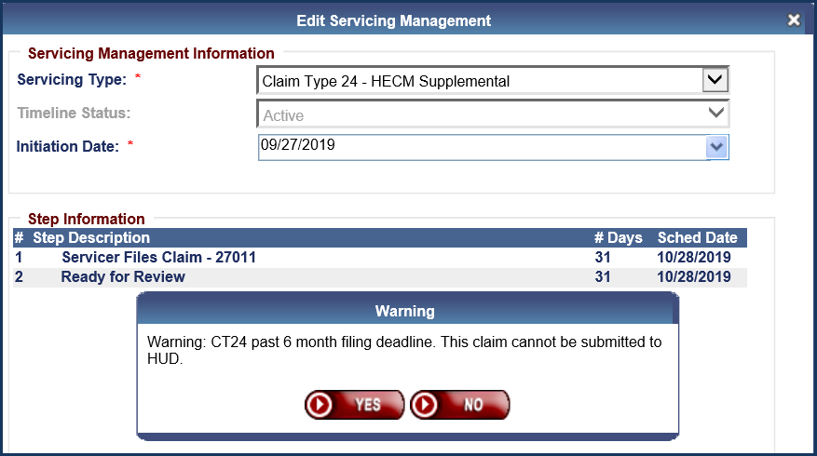

Figure 3: Warning message on CT24 after 6 months without extension or with expired extension

1. When servicer OPENS a CT24 timeline after the 6 month deadline has passed and optional step “**Allow CT24 after 6 month deadline”** has not been added by HUD or is past the 30 day deadline, the popup warning message is displayed stating “Warning: CT24 past 6 moth filing deadline. This claim cannot be submitted to HUD.”. **The servicer may still work the CT24 but will not be able to submit it to HUD unless permission is granted.**

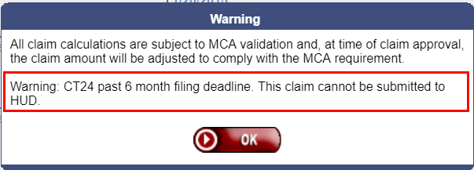

Figure 4: Warning message on opening CT24 after 6 months without extension or with expired extension

1. If HUD grants permission for the CT24 to be filed by adding the optional step “Allow CT24 after 6 month deadline”, then the servicer may submit the CT24 to HUD within 30 days of the date the step was added. The usual popup windows will be displayed after servicer clicks “Finalize and Submit Claim”. **TIP:** All CT24 validations must pass for the claim to be allowed. **HUD may grant multiple 30 day extensions if HUD deems necessary.**
2. If the optional step is **not added by HUD** OR the step was added by HUD with a step completion date **older than 30 days ago**, a hard stop claims validation message will prevent the CT24 from being submitted to HUD: “**CT24 cannot be filed more than 6 months after the Parent Claim Paid date**.”

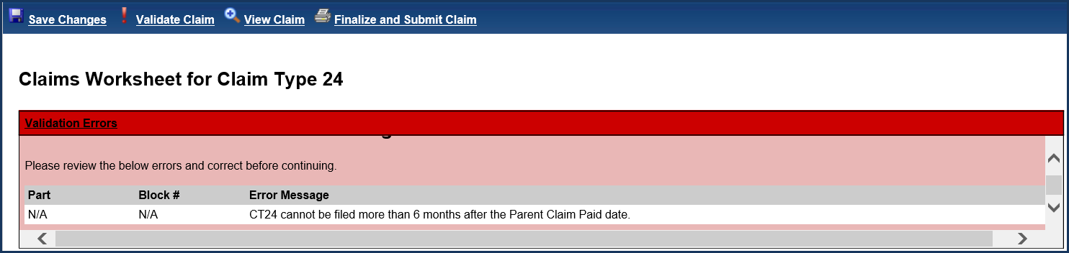

Figure 5: Hard Stop Validation message on CT24 after 6 months without extension or with expired extension

Each time the servicer clicks “Finalize and Submit Claim” on a CT24 and receives the hard stop validation message; an auto-note will be saved to the loan stating “CT24 - CT24 cannot be filed more than 6 months after the Parent Claim Paid date.”

1. When HUD user Approves the claim after servicer initially submits the claim and the alert was added; a popup window will be displayed stating “This CT24 was filed after the 6 month Supplemental Claim Filing Deadline of MM/DD/YYYY. Are you sure you want to Approve this claim?”. The HUD user will click YES to approve or NO to cancel.

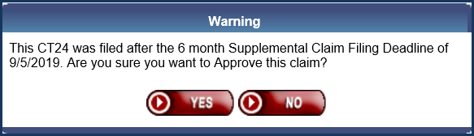

Figure 6: HUD Approval confirmation to approve after 6 month deadline

## Allow negative value in Block 108 on Claim Type 24

Going forward, HERMIT CT24 Block #108 field will accept a negative value entered by the servicer. This will assist servicers when the servicer errors in reporting the value or sale price in Block 108 on the initial parent claim. If a negative value is entered into this field, the total claim amount will be **increased** instead of decreased. The comment on the CT24 Claim Form displayed underneath Block #108 was updated to “* Enter the difference from original claim (Range of -$650,000.00 to $650,000.00)”.

## Multiple / Subsequent Claim Type 24 Supplementals

Previously, only one CT24 Supplemental claim was permitted on a loan. An enhancement was made to allow Multiple / Subsequent CT24’s in HERMIT when permission is granted by an authorized HUD user.

Multiple / Subsequent CT24 is only allowed if the following apply:

1. Authorized HUD user grants permission for a multiple / subsequent CT24 by adding optional step “Allow Subsequent CT24” to the *prior* CT24 timeline
2. Servicer submits the claim to HUD within 30 days of the optional step completion date (initial claim filing only, 30 day deadline not applicable for CT24 pended by HUD)
3. All other claims on the loan have claim status “Claim Paid”
4. There is not a paper claim record on the loan

| **Action by User** | **Allow CT24 after 6 month deadline** | **Allow Subsequent CT24** |
| --- | --- | --- |
| Servicer Initiates new CT24 | Servicer **may** initiate / create CT24 timeline before HUD grants permission for the claim to be submitted | NO: Servicer cannot initiate / create CT24 timeline until HUD has granted permission |
| Servicer Updates / Works new CT24 timeline | Servicer **may** work CT24 timeline before HUD grants permission for the claim to be submitted | NO: Servicer cannot work CT24 timeline until HUD has granted permission |
| HUD grants permission: adds optional step | HUD adds optional step to grant permission: servicer must submit the claim within 30 days | HUD adds optional step to grant permission: servicer must submit the claim within 30 days |
| Servicer submits claim to HUD | If within 30 days of HUD granting permission, and all other validations pass; then servicer may submit claim to HUD | If within 30 days of HUD granting permission, and all other validations pass; then servicer may submit claim to HUD |

Figure 7: Chart of actions to file CT24 after 6 month deadline

A new alert “Multiple Claim Type 24” was added to HERMIT. The alert will be added to the loan when the servicer completes the “Servicer Files Claim 27011” step on the subsequent CT24 timeline.

**Example:**

1. *Outside of HERMIT*: Servicer requests permission to submit a multiple / CT24 to HUD
2. *Outside of HERMIT*: HUD reviews servicer request. If HUD determines the claim is allowed, the remaining steps must occur:
3. Authorized HUD Claims user grants permission for the Subsequent CT24 by adding optional step “Allow Subsequent CT24” to the *prior* CT24 timeline.
4. Servicer initiates / creates the new subsequent CT24 timeline; works the claim. The claim will not display the Subsequent CT24 popup warning message.
5. Servicer submits the claim to HUD (by clicking “Finalize and Submit Claim” on the claim form) **within 30 days of the date HUD added the optional step “Allow Subsequent CT24”.** The claim will not display the Subsequent CT24 popup warning message.
   1. **TIP:** all CT24 validations must pass for the claim to be allowed.

**TIP**: if a large volume of subsequent CT24’s is expected, servicer may wish to break the population up into smaller lists to ensure there is sufficient time for the servicer to complete the claim filing within 30 days of HUD adding the step to the timeline.

**Subsequent CT24 Pop Up errors and hard stop validation message**

1. If HUD does not grant permission **OR** if permission is granted but the servicer does not **initiate / create** the CT24 to HUD within 30 days of the optional step date; the following hard stop claims validation message will be displayed: “There is already an active CT24 without the necessary optional step for a Subsequent CT24 to be permitted”

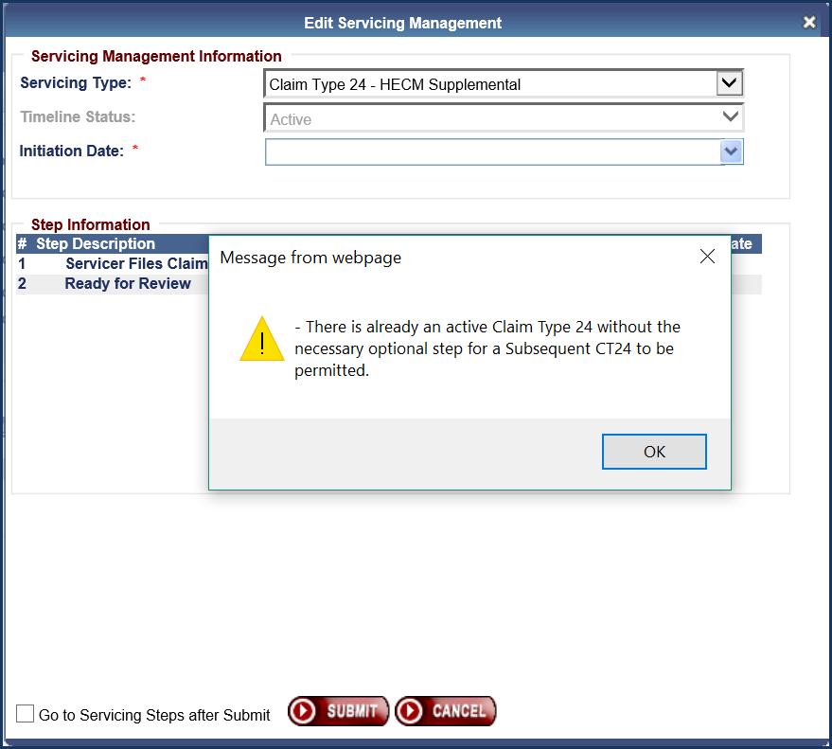

Figure 8: Subsequent CT24 initiation error message

1. On a subsequent CT24 already initiated; if permission was granted but the servicer misses the 30 day deadline to **submit** the CT24; the following hard stop claims validation message will be displayed: “The timeframe to submit the CT24 has passed and cannot be filed.”

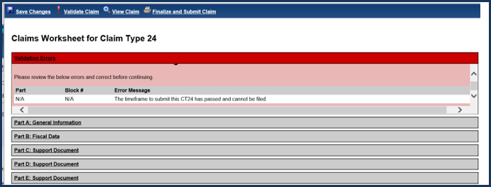

Figure 9: Subsequent CT24 hard stop validation error message

# NSC Related Changes

## New Request- Substitution of Collateral Timeline

Two new timelines have been added to the HERMIT system. Both are called “Substitution of Collateral”. One is under Endorsed/Requests and the other is under Assigned/Requests.

### A. New timelines Substitution of Collateral – Endorsed loans

1. New timeline “Substitution of Collateral” has been added to Endorsed/Request/Setup area. The timeline can be added to loans that have a Case Status of Pending IMIP Payment, Pending Endorsement, Endorsed and Terminated
2. New timeline has been added to Endorsed/Request/Setup area.
3. The new timelines are called “Substitution of Collateral”
4. Following fields will be added when the timeline is created

* Servicing type: Required field
* Timeline Status: Defaults to “Active” – Read only field
* Initiation Date: Required field – Date entered must be <= Current Date
* Responsible Party – Optional field (Not available for Servicers)
* Reason for Substitution of Collateral – Dropdown menu
  + Earthquake
  + Fire
  + Flood
  + Hurricane
  + Mud Slide
  + Other – See Notes
  + Tornado
  + Tropical Storm
  + Tsunami
* Recoverable Funds Total
* Description of Event That Occurred

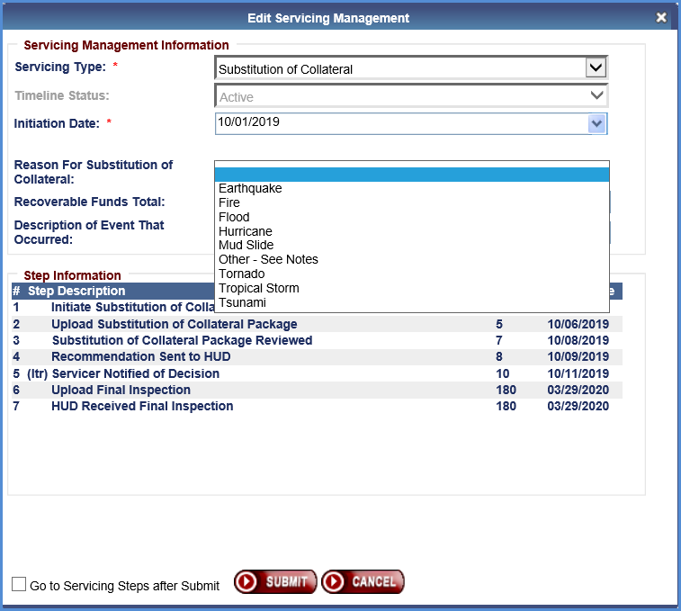

Figure 10: Substitution of Collateral Timeline Initiation for Endorsed Loan

1. Only one active timeline is allowed at a time. Following error message will be displayed if the user tries to enter multiple timelines on a loan: **“Error**: There is already an active Substitution of Collateral timeline on this loan. Loan Skey: XXX.”
2. Following steps have been added to this new timeline. See attached spreadsheet with Substitution of Collateral Timeline steps.



1. Following roles can create and manage Substitution of Collateral timeline.

* CLS-First Mortgage
* CLS-Supervisor/Management
* HUD NSC-Mgr
* Servicer-Mgr
* Servicer-Staff

1. User will be able to search New Servicing Type “Substitution of Collateral” timelines under Endorsed/Requests Search page
2. User will be able to edit the following fields listed below on the “Substitution of Collateral” Timeline Servicing Mgmt tab and will be able to inactivate the timeline

* Timeline Status
* Responsible Party (Not available for Servicers)
* Reason For Substitution of Collateral
* Recoverable Funds Total
* Description of Event That Occurred

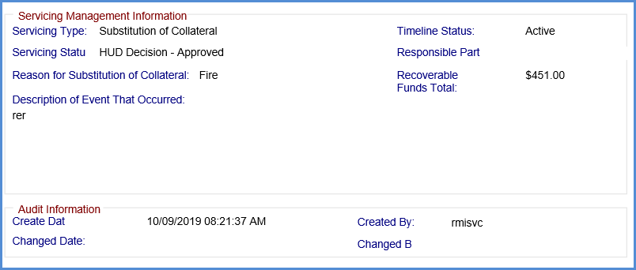

Figure 11: Substitution of Collateral Servicing Management

1. New decision letter will be generated to send to the Servicers when the request is either Approved, Denied, or Pending Additional Information. Example of an approval letter is attached below.

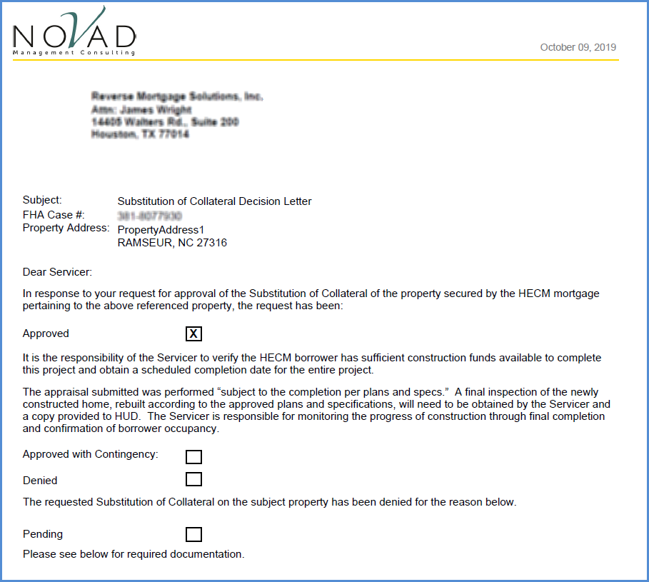

Figure 12: Substitution of Collateral Servicing Letter

1. User will be able to upload documents using timeline steps.
2. A new document type called “Substitution of Collateral Package” (Document Skey: 1810) for “Upload Substitution of Collateral” step has been added.
3. A new document type called “Substitution of Collateral” (Document Skey: 1820) for “Servicer Notified of Decision” step has been added.

### B. New timelines Substitution of Collateral – Assigned loans

1. New timeline “Substitution of Collateral” has been added to Assigned/Request/Setup area. The timeline can be added to Assigned loans and Terminated loans with Servicer = 9999909990.
2. Following fields will be added when timeline is being created

* Servicing type: Required field
* Timeline Status: Defaults to “Active” – Read only field
* Initiation Date: Required field – Date entered must be <= Current Date
* Responsible Party – Optional field
* Reason for Substitution of Collateral – Dropdown menu
  + Earthquake
  + Fire
  + Flood
  + Hurricane
  + Mud Slide
  + Other – See Notes
  + Tornado
  + Tropical Storm
  + Tsunami
* Recoverable Funds Total
* Description of Event That Occurred

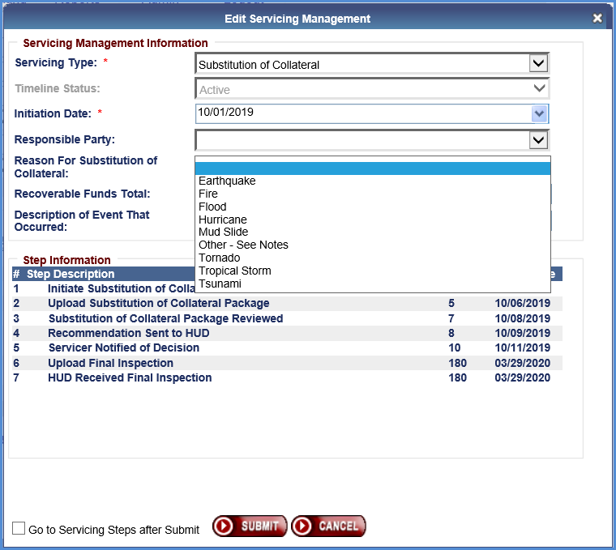

Figure 13: Substitution of Collateral Timeline Initiation for Assigned Loan

1. Only one active timeline is allowed at a time. Following error message shall be displayed if user tries to enter multiple timelines on a loan.

**Error**: There is already an active Substitution of Collateral timeline on this loan. Loan Skey: XXX

1. Following steps have been added to this new timeline. See attached spreadsheet with Substitution of Collateral Timeline steps.



1. Following roles can create and manage Substitution of Collateral timeline.

* CLS-Cash
* CLS-Cash Supervisor
* CLS-Default
* CLS-First Mortgage
* CLS-Supervisor/Management
* HUD NSC-Mgr
* HUD SF Premium Mgr
* HUD SF-Staff

1. User will be able to search New Servicing Type “Substitution of Collateral” timelines under Assigned/Requests Search page
2. User will be able to edit following fields listed below on the “Substitution of Collateral” Timeline Servicing Mgmt tab and be able to inactivate the timeline

* Timeline Status
* Responsible Party
* Reason For Substitution of Collateral
* Recoverable Funds Total
* Description of Event That Occurred

1. User will be able to upload documents using timeline steps.
2. A new document type called “Substitution of Collateral Package” (Document Skey: 1810) for “Upload Substitution of Collateral” step

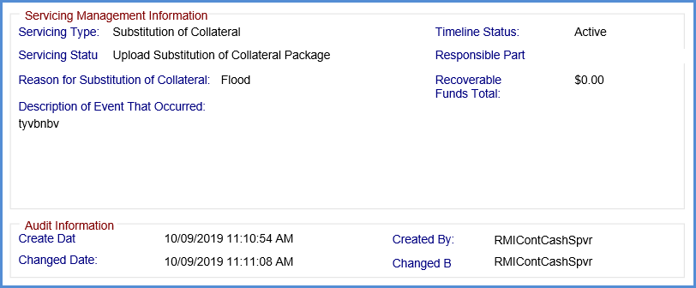

Figure 14: Substitution of Collateral Servicing Management

## New Add new steps to Claim Type 22 - Assignment timeline

Two new servicer steps have been added to the Claim Type 22 - Assignment timeline. Now HERMIT will provide access to the original Servicer who started the Claim type 22 timeline to complete these new steps when the Servicer is changed to HUD. After loan status is changed to Assigned, Servicer will no longer have access to Claim Steps page.

**Add two timeline steps to Claim Type 22 - Assignment**

1. New steps will be available to new timelines created on or after release 5.9 and will be triggered by HUD Issued Preliminary Title Approval step.

* Receipt of Recorded Assignment from County
  + The scheduled date for this step will be set to 5 months (150 days) for all loans with FHA Case # assigned date before 9/19/2017.
  + The scheduled date for this step will be set to 11 months (330 days) for all loans with FHA Case # assigned date on or after 9/19/2017
  + The scheduled date for this step will be set to 5 months (150 days) for all loans with FHA Case # assigned date is NULL.
* Sent Recorded Assignment to HUD
  + The scheduled date for this step will be set to 1 months (30 days from Receipt of recorded assignment from county) for all loans with FHA Case # assigned date before 9/19/2017.
  + The scheduled date for this step will be set to 1 month (30 days from Receipt of recorded assignment from county) for all loans with FHA Case # assigned date on or after 9/19/2017
  + The scheduled date for this step will be set to 1 month ((30 days from Receipt of recorded assignment from county) for all loans with FHA Case # assigned date that is NULL.

1. See the spreadsheet below for all Claim Type 22 – Assignment timeline steps with details. Two new steps were added to the spreadsheet.



1. The scheduled date for the “Recorded Assignment Received” step was updated to be 15 days after the step “Sent recorded assignment to HUD”.

## Servicer access to loan with Servicer = HUD via Endorsed/Claims/Search page

1. Servicer will be allowed to access a loan in Case Status Endorsed and with Lender = HUD via Endorsed/Claims/Search page.
2. If you are the prior servicer on the loan and loan is set to Servicer = 9999909990 (NOVAD Management Consulting LLC) users will be allowed to access this loan via Endorsed/Claims/Search page.
3. HERMIT will allow servicers to complete Servicer steps under Claim Type 22 timeline.
4. Servicers will be able to see following tabs on the left menu.

* Claims Steps
* Notes
* Documents

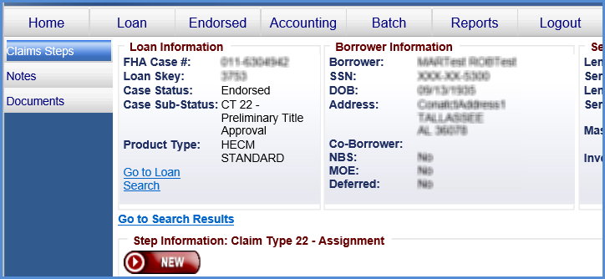

Figure 15: Servicer view of CT22 Assignment timeline after transfer

1. When HUD completes “HUD Issues Final Title Approval” step under Claim Type 22 timeline, Servicer will no longer have access to that loan.

## New Add new step to Write-Off Timeline

1. A new optional step “Denial of Write-Off by HUD” has been added to Write-Off timeline
2. This will apply to all Active Pending timelines and new timelines created on or after release 5.9.
3. Current template step “Approval of Write-Off by HUD” is updated to an optional step
4. See following spreadsheet below for all Write-Off timeline steps with details. Updated steps are added to the spreadsheet.



1. Script will be written to delete existing template step “Approval of Write-Off by HUD” from all active pending timelines where complete date is null. “Approval of Write-Off by HUD” will be available as optional step after the release.